ONLINE TECHNOLOGY LAB

GROUP G

STUDENTS RECORD

1. INTRODUCTION

As we all know, computer is one of most helpful electronic devices that manage the school records by storing information in a way that allows for rapid sorting, searching and retrieval of data. We can use the web-based system to help the school admin to manage the record of the student. It allows the administrative staff to make their works easier. Besides reducing the use and handling of papers, an additional advantage of a computerized system is that it can help to analyze the recorded data and quickly generate the detailed school management information such as lists of students.

With the use of the functionality of HTML-CSS, we were able to design more appropriate friendly user interface and easy to navigate for the user. The connection between the web-management and data source we used the database my sql as the local host connection. The python was used for the web development of the entire process of the output system.

1. OBJECTIVES
   1. To develop Students Record System applying Html – Css Language, Python Programming and MySQL Database.
   2. To create a web-design to express the visualized concept with Use Case, Activity, Conceptual class, and Detailed class diagrams.
   3. And to apply all the lessons learned in this course.
2. UML

USE CASE DIAGRAM

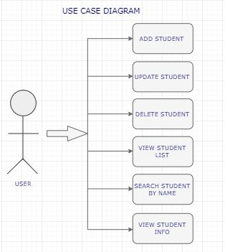

ACTIVITY DIAGRAM

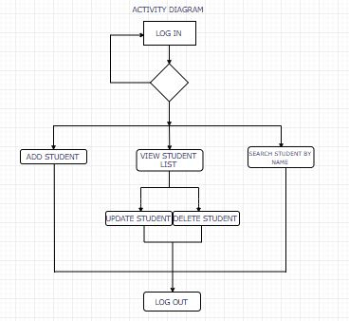

CONCEPTUAL CLASS DIAGRAM

